256 – 258 Boundary Road, St Helens, WA10 2PT
8-bedroom HMO – with a 25 year full repair and insure lease. Inflation proof, the lease increases with the LHA rate
GIA –310m2
Rent | Current Rent |  | Rent Increase in April |  | Term remaining
Rent | PCM | Annually | PCM | Annually
Commercial 1 | £1,100 | £13,200 | £1,100 | £13,200 | End of lease 31-12-28
Commercial 2 | £650 | £7,800 | £650 | £7,800 | End of lease 31-10-27
HMO | £3,467 | £41,604 | £3,917 | £47,004 | End of lease 04-07-28
Total | £5,667 | £62,604 | £5,667 | £68,004

The property underwent a complete refurbishment five years ago, including a back-to-brick renovation. Both commercial units are currently occupied by businesses in the beauty industry, each on full repairing and insuring (FRI) leases in a high-demand area.
Unit 1's tenant recently moved in and invested approximately £15,000 in renovations to tailor the space to her style, indicating a long-term commitment to the property. This unit is leased on an FRI basis.
Unit 2 is involved in the beauty industry. This unit is also on an FRI lease.
The property additionally features a luxury HMO conversion on the ground floor, with an open-plan living room and eight bedrooms on the first floor. The HMO is leased to a care provider on an FRI lease, who covers all maintenance costs, including boiler, roof, and other upkeep. The lease includes rent adjustments in line with increases in Local Housing Allowance (LHA)
The property was designed with durability in mind, as there was no intention to sell. Key enhancements include:
- Additional insulation for walls, ceilings, and floors
- Soundproofing between ceilings and walls
- CCTV installation
- New flat roof
- Five en-suite bathrooms
- 300-liter unvented cylinder
- Commercial grade carpets.
- Commercial doubled charged tiles to the ground floor including entrance.
- Tile skirting board to the downstairs.
- Good British brands used like MK & Ansell.
- Magnet kitchen inc breakfast bar.
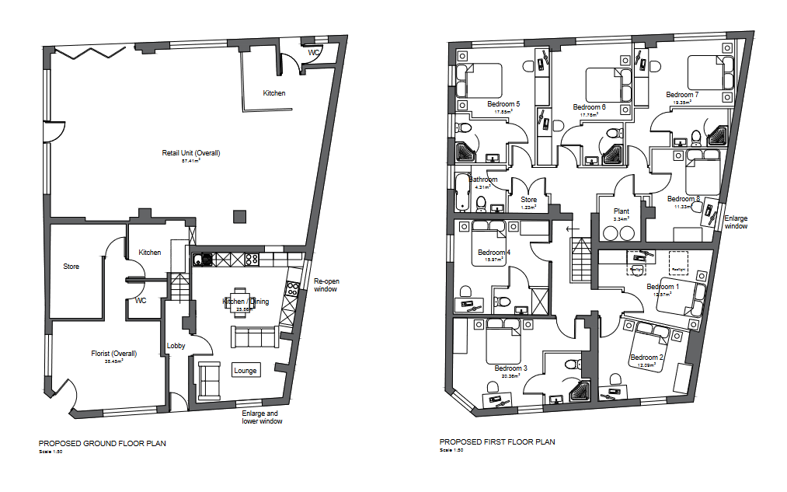

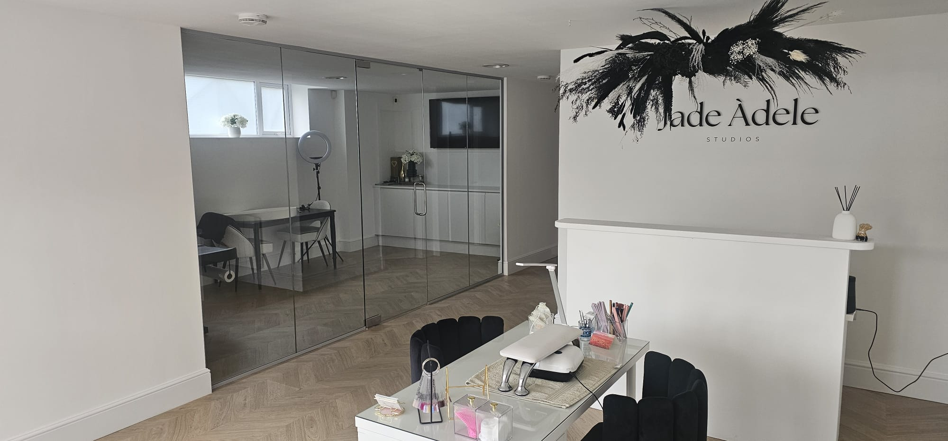
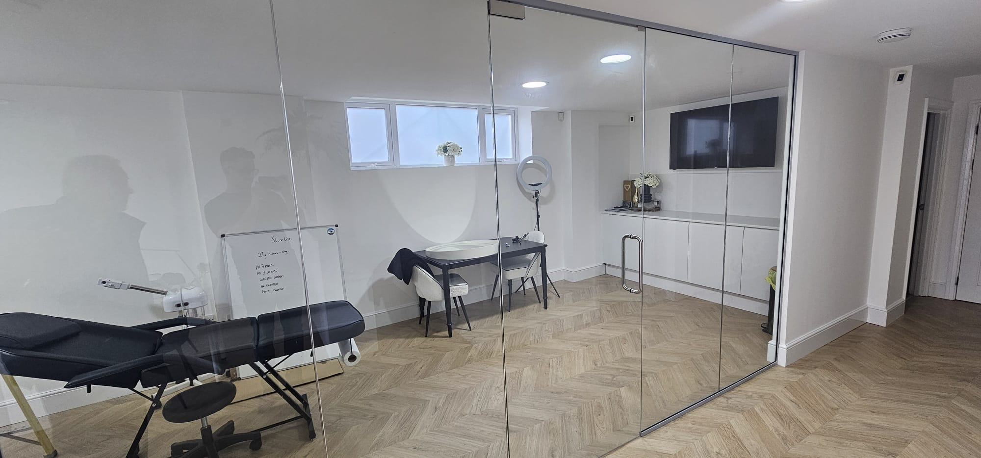
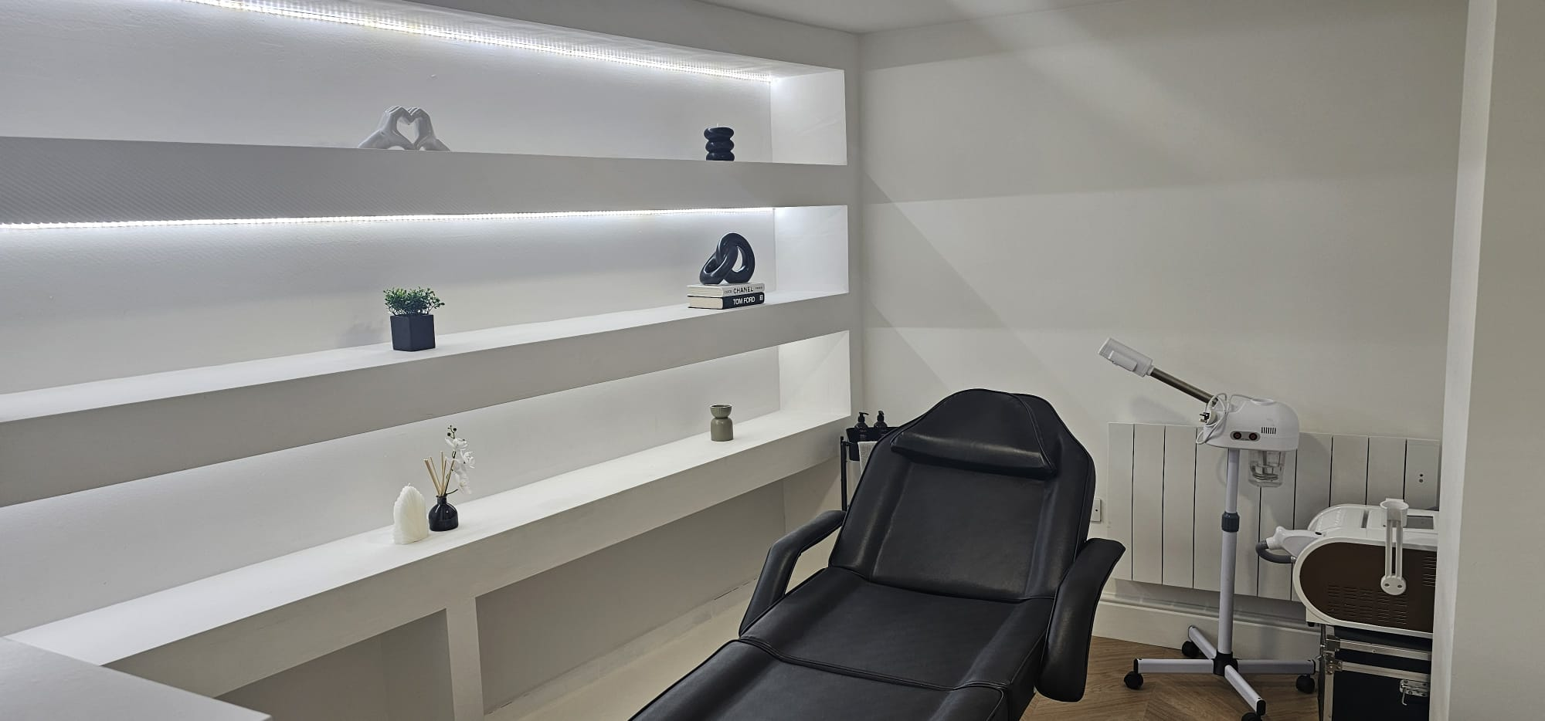
Commercial 1

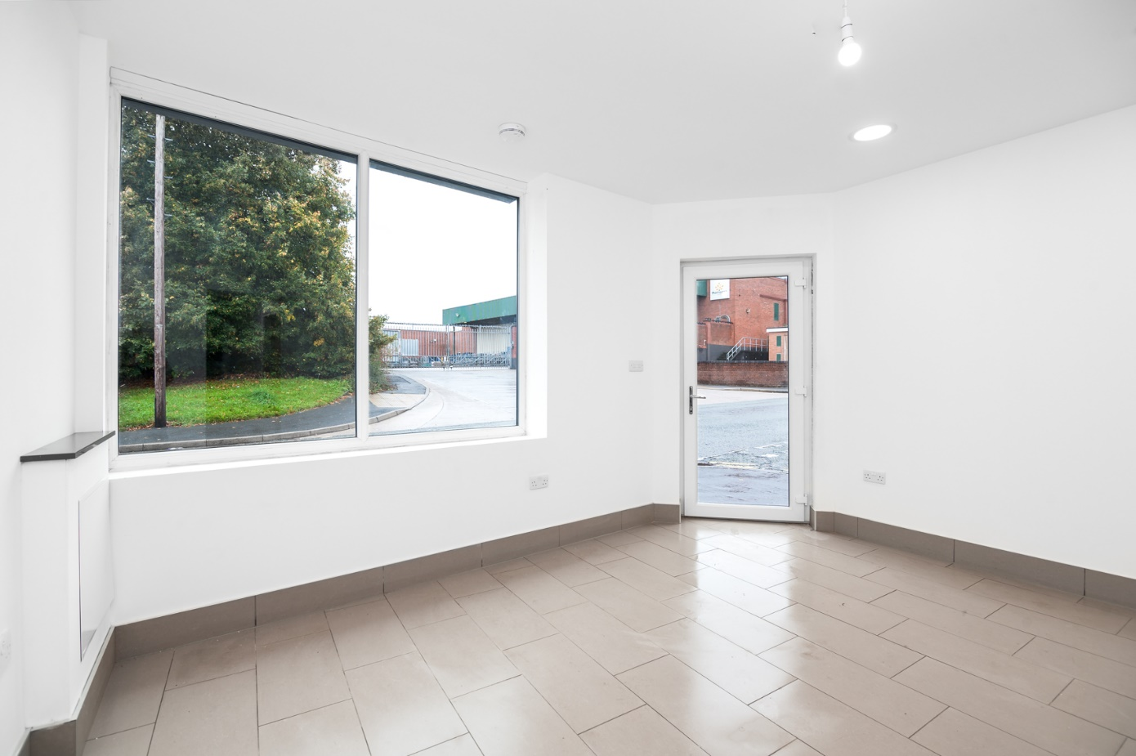
Commercial 2
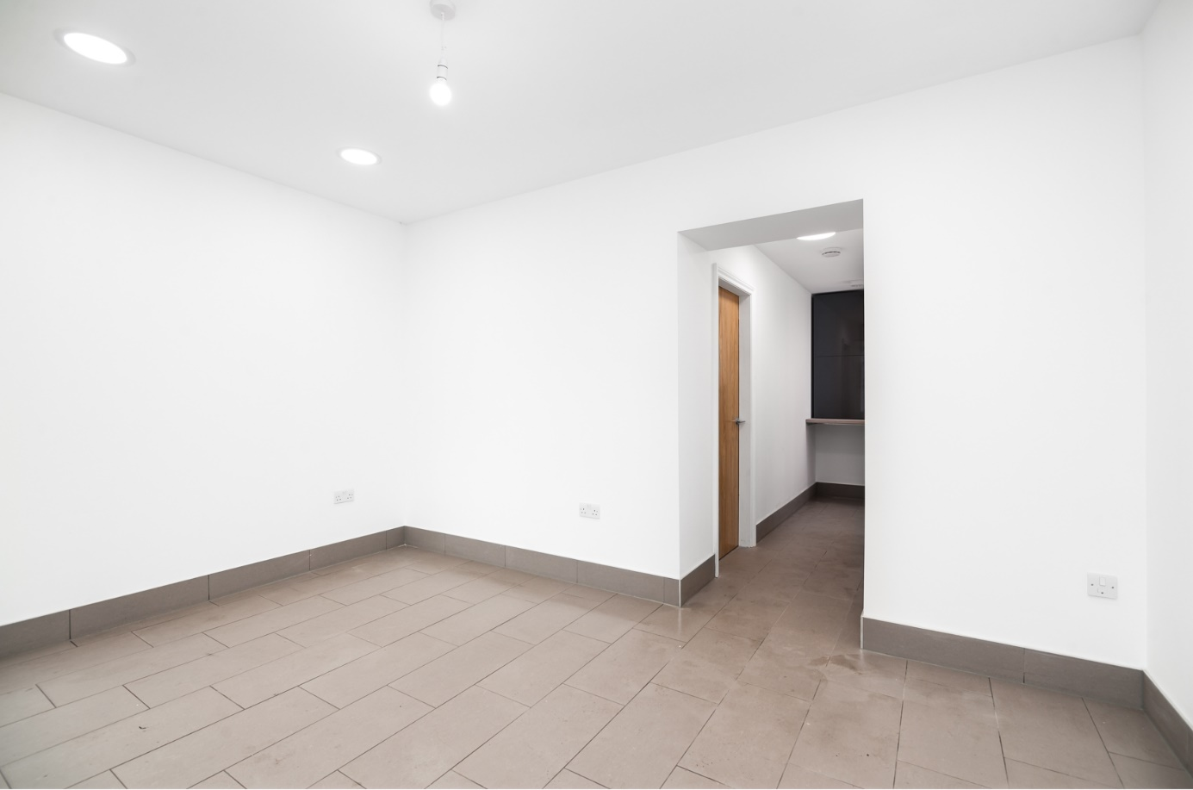
Commercial 2
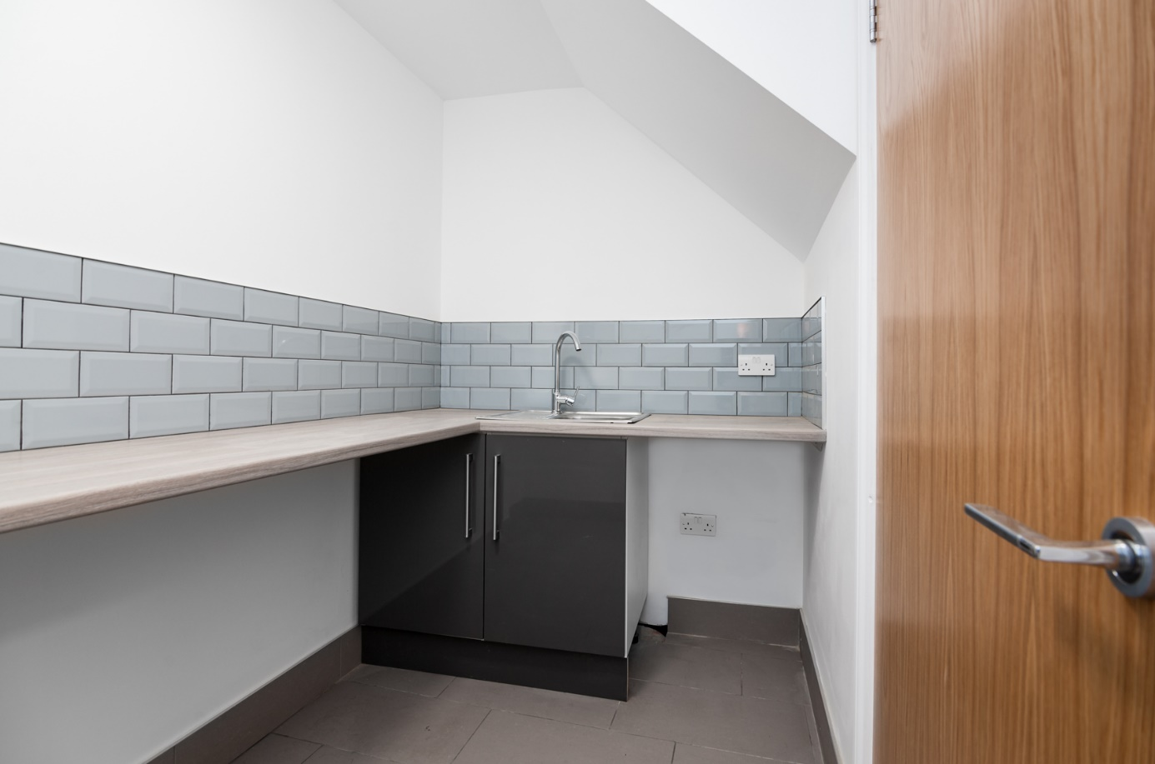
Commercial 2
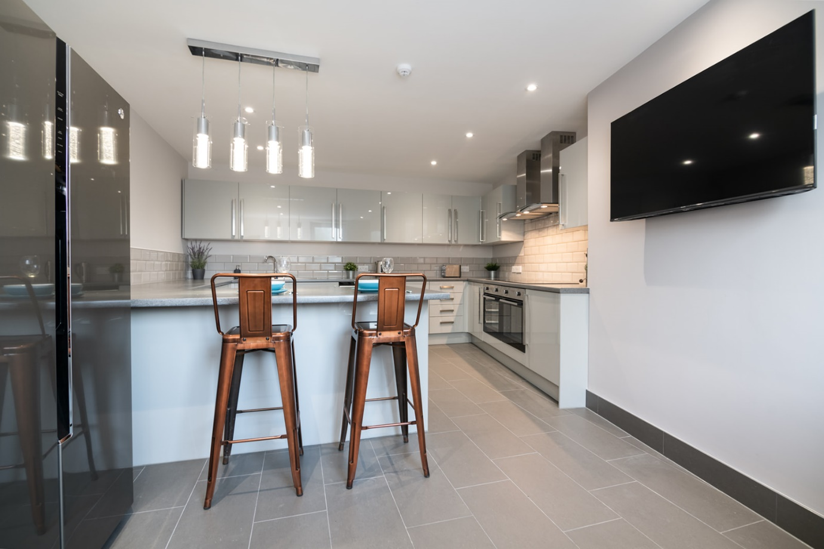
HMO – kitchen
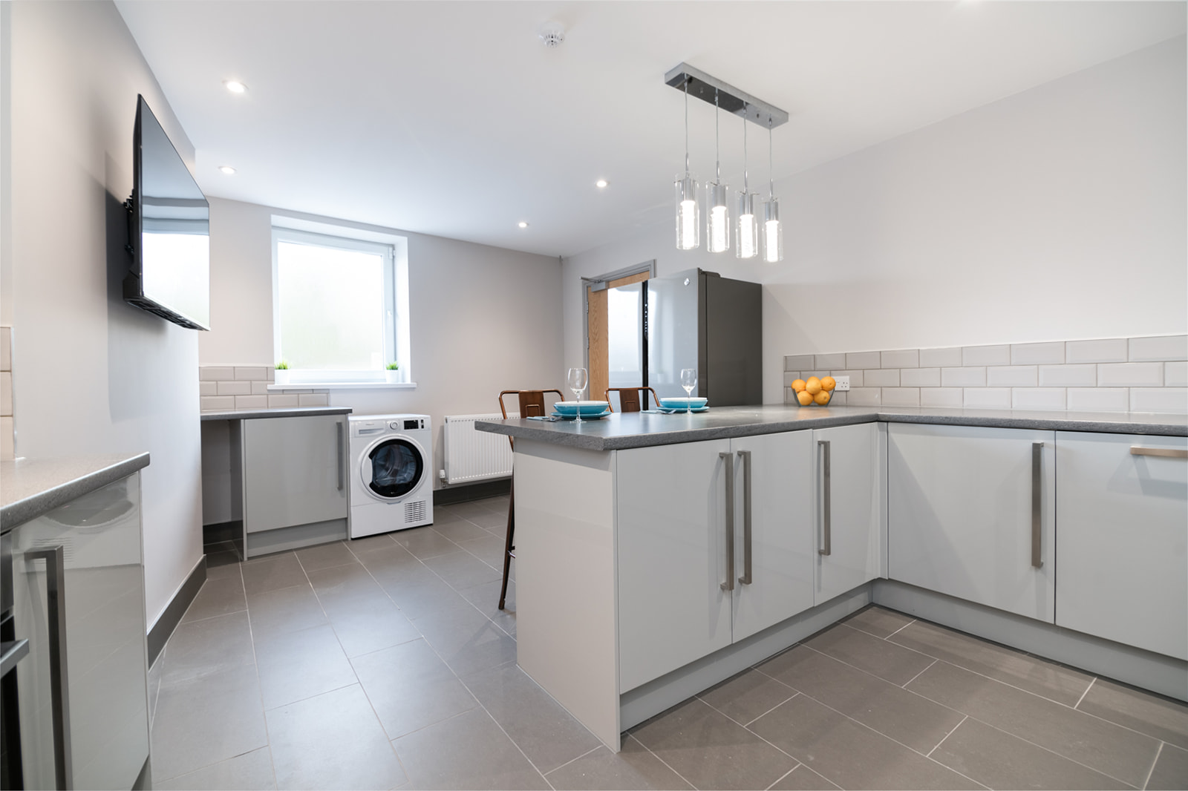
HMO – kitchen
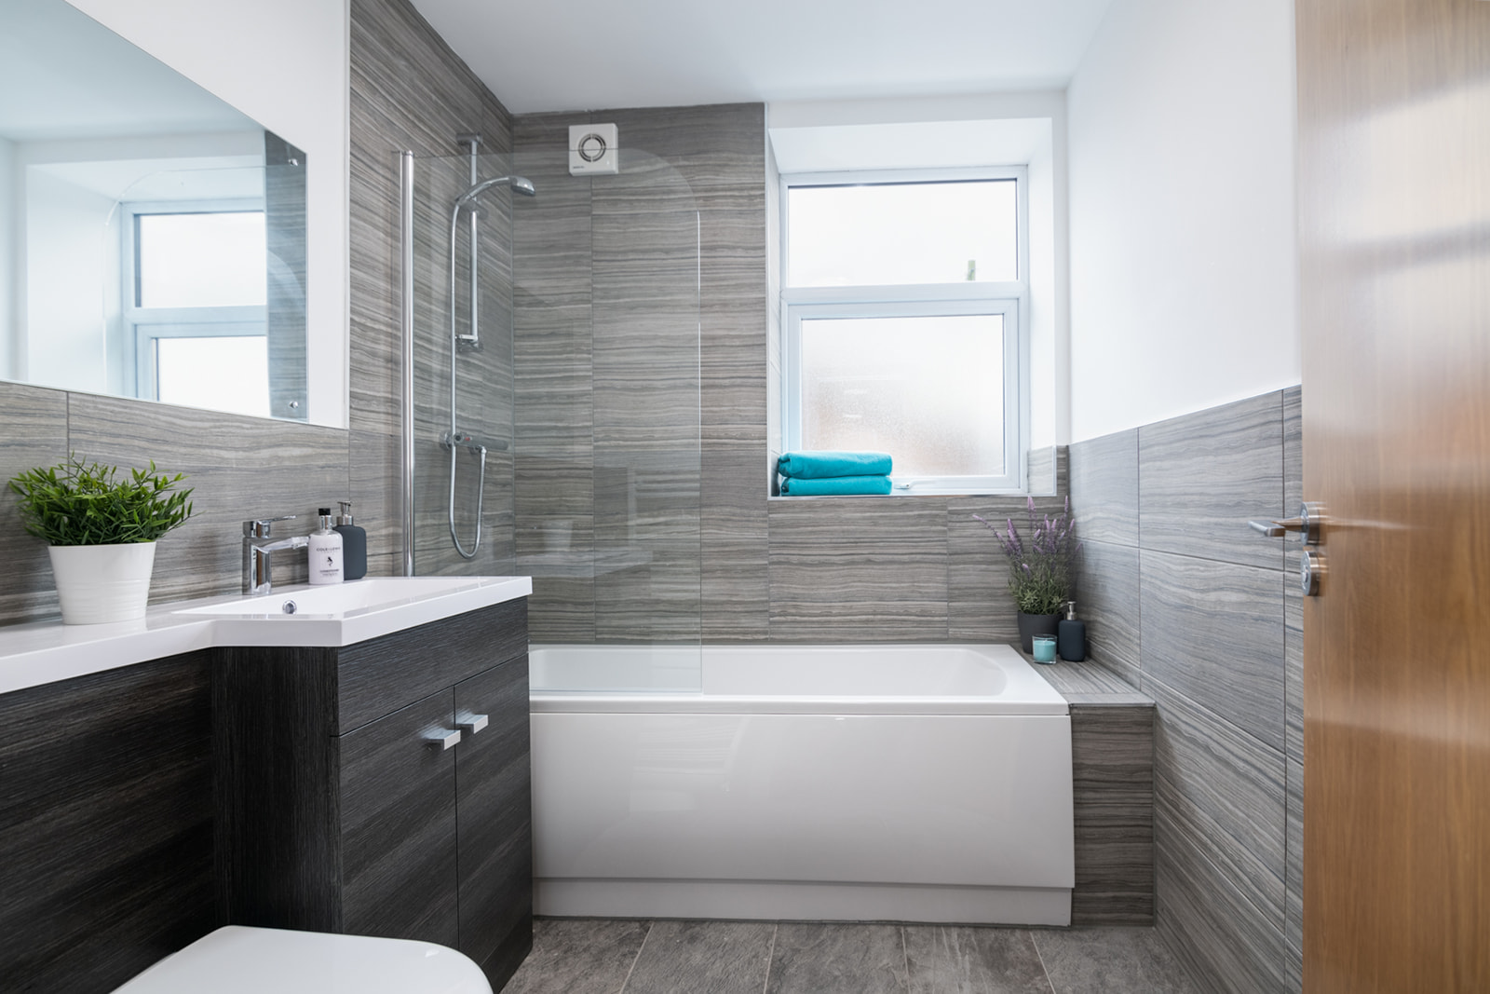
HMO – shared bathroom
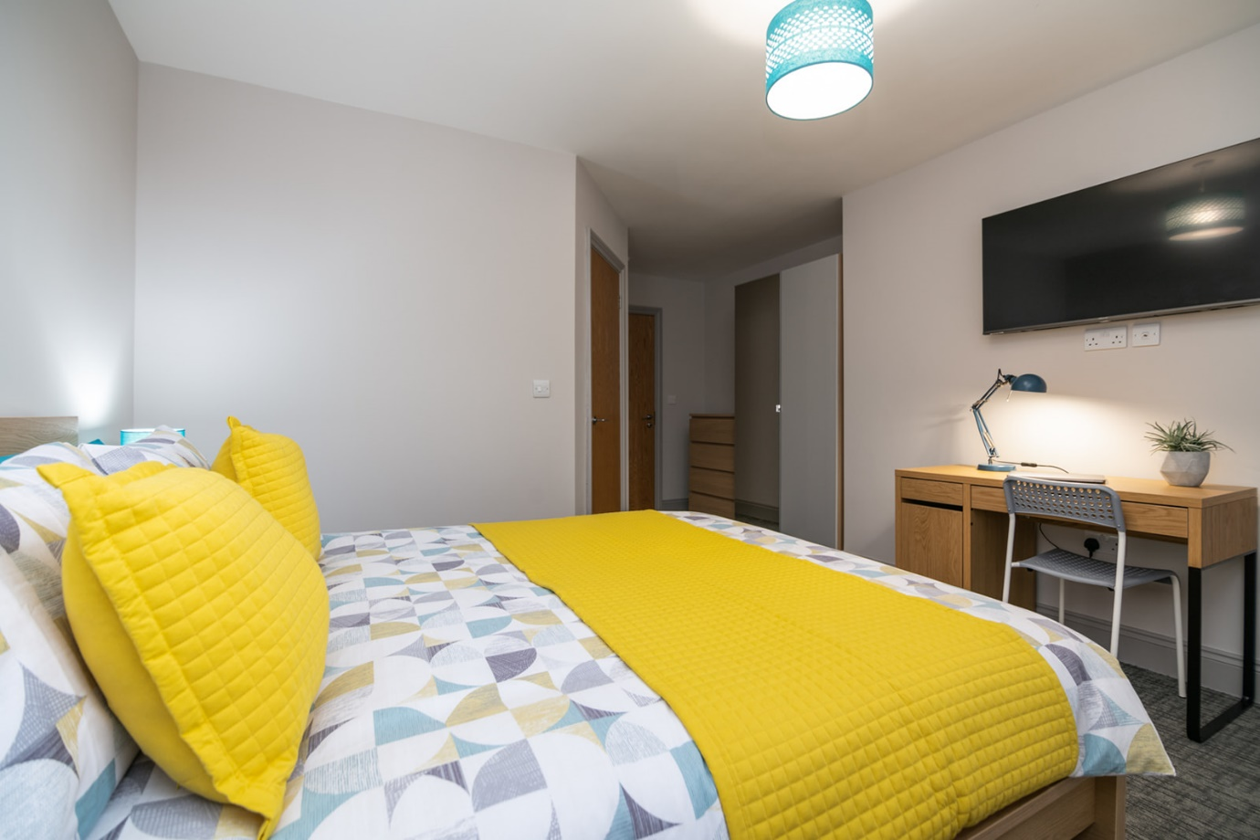
HMO – bedroom
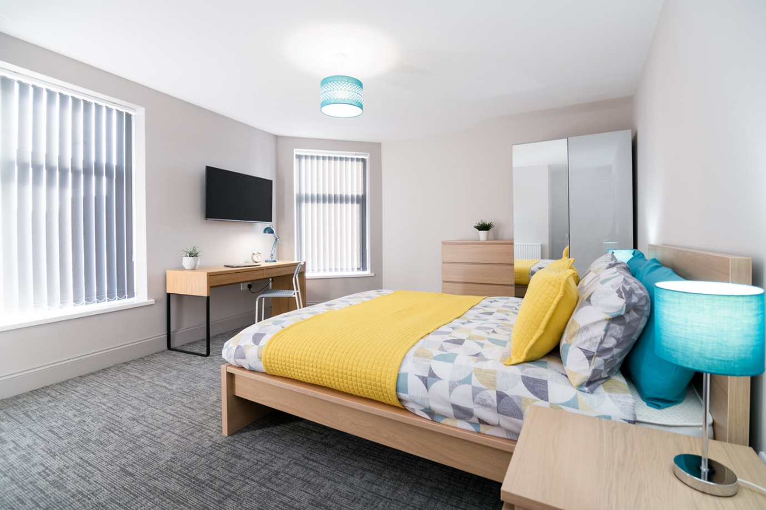
HMO – bedroom
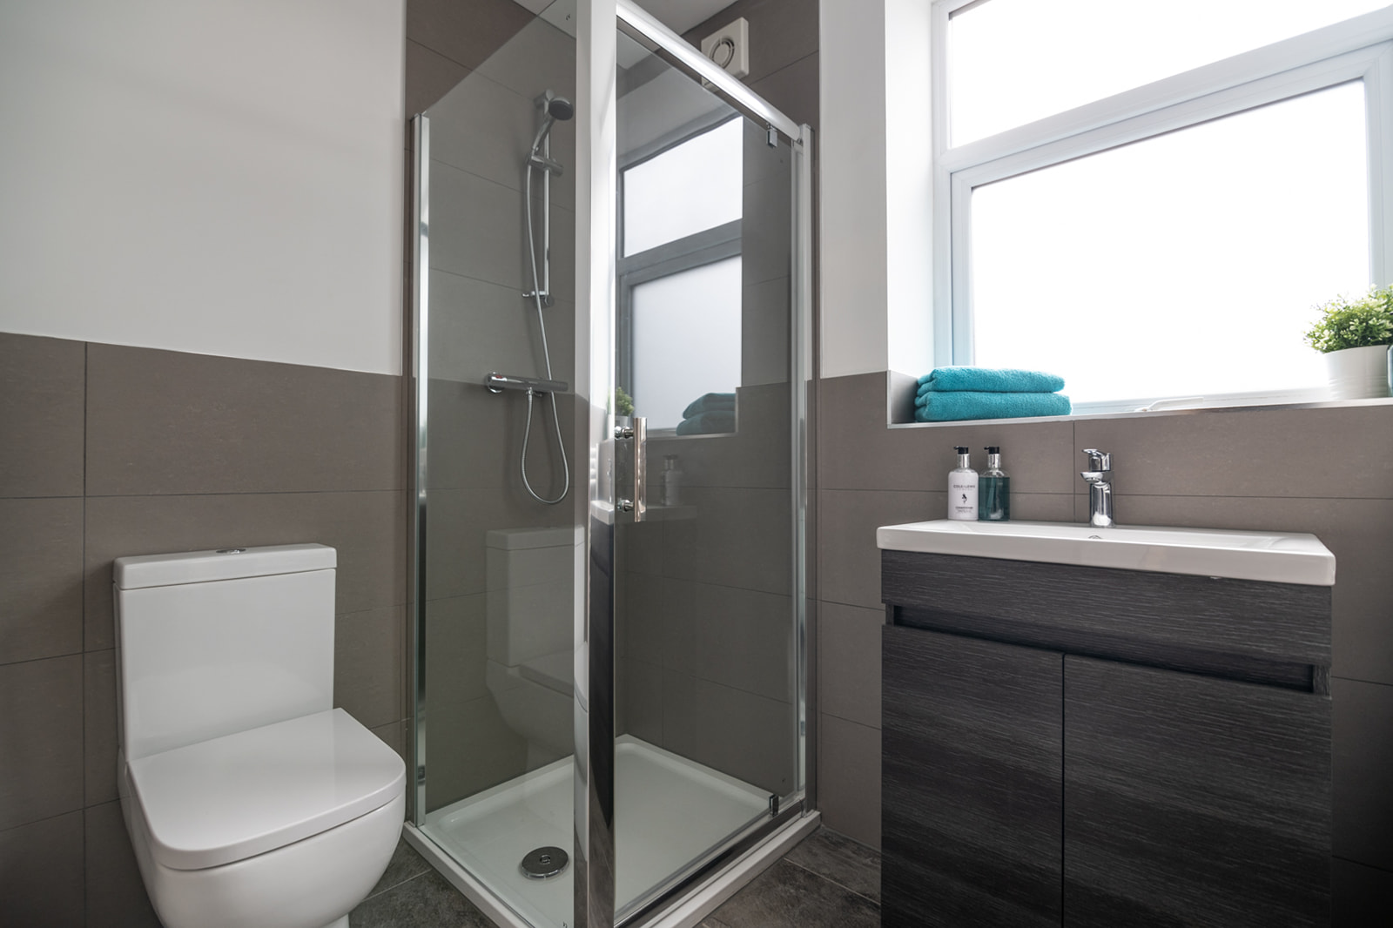
HMO – ensuite

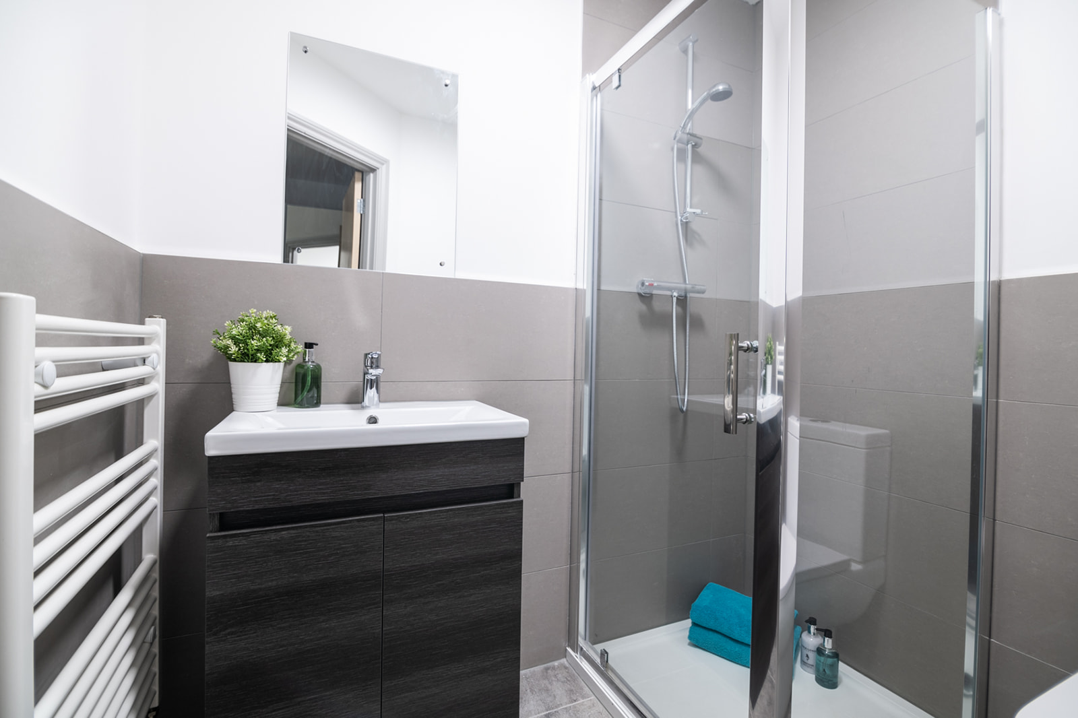
HMO – ensuite
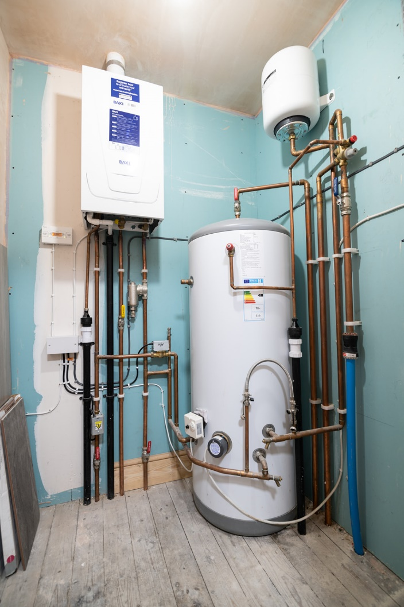
HMO – plant room

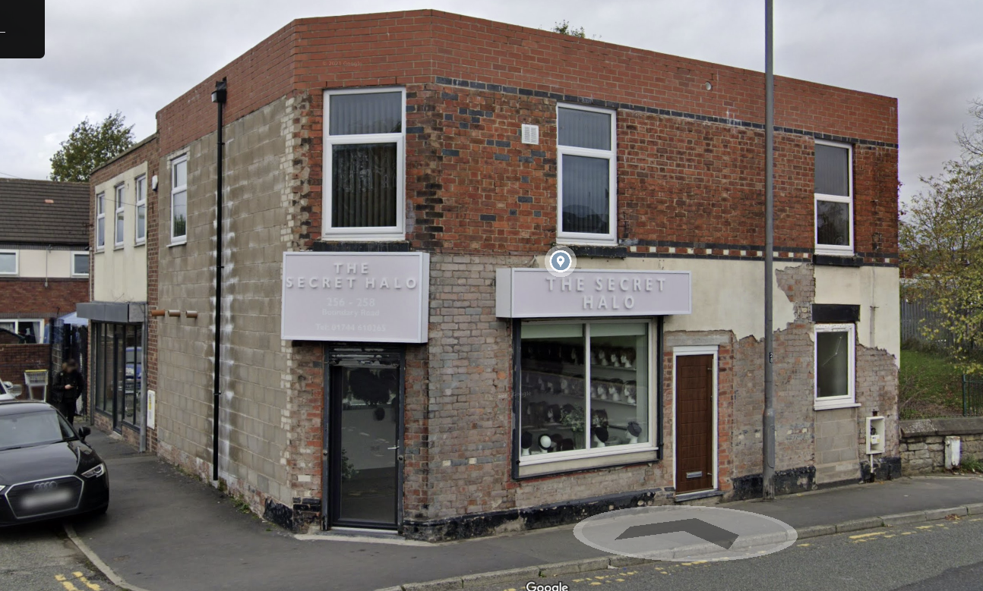
We are in the process of getting the render complete on the outside of the building. We are just waiting for a bit of dry weather, but this will be completed prior to building being sold.
The property will a new silicone-based render, K Rend.

